Reference | Value | Qty
A1 | Arduino_Nano v.3 (old bootloader) ATMEGA328P. Software already installed | 1
Circuit board | Prioriton 1.0 Board | 1
LED Matrix | WS2812 LED 5050 RGB 8x8 64 LED Matrix forArduino | 1
C1,C2,C5,C8 | 100nF | 4
C3,C6 | 220nF | 2
C4 | 100uF | 1
C7 | 1nF | 1
J1, J2, J3 | Clock_IN | 3
USB Socket | +5v in | 1
R1 | 100K | 1
R2,R3 | 10K | 2
R4,R7 | 330R | 2
R5,R6 | 680R | 2
R8 | 270R | 1
RV1,RV2 | 50K Potentiometer RK097k | 2
SW1 | 12x12 Tact Switch (12mm height) | 1
SW3 | RotaryEncoder_Switch | 1
Misc Hardware
 | Nuts for Potentiometer | 2
 | Knurled nuts for Jack Sockets | 3 (+1)
 | 3x foam pieces | 2+1
 | 2x Variable resistor knobs | 2
 | 1x Rotary encoder knob | 1

Resistors
100K | 10K | 680R
X1  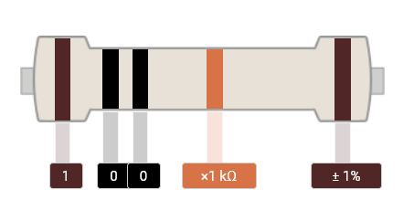 | X2  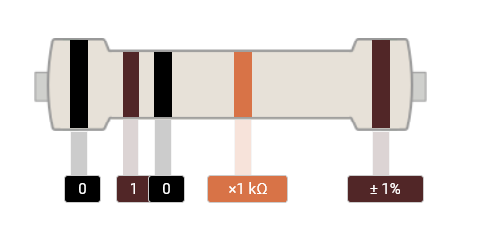 | X2  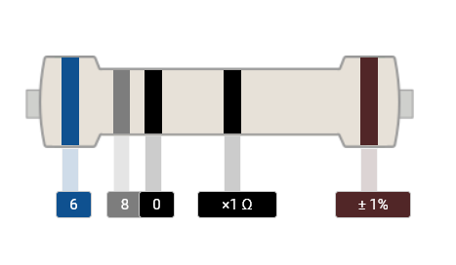
330R | 270R
X2  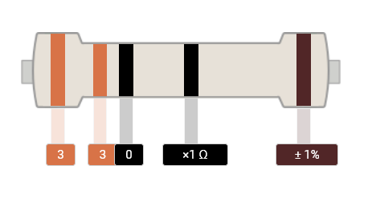 | X1  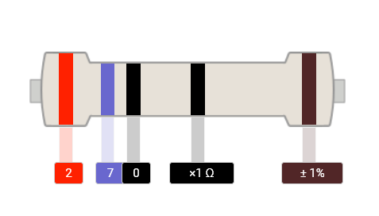

Capacitors
100uF | 220nF | 100nF | 1nF
x1 | Code 224  X2 | Code 104  x4 | Code 102  X1

In this little bag

- 1x Button
- 2x 50K Variable Resistor (with a green base)
- 1x Rotary Encoder (with a blue base)
- 3x 3.5mm Jack Sockets
- Blue, Red and Black wires
- 1x USB Socket

- 4x nuts for the jack sockets (one is a spare in case one rolls on the floor or you overtighten it)
- 2x nuts for the Variable Resistor (the rotary encoder does not have a nut on it)
- 2x Variable Resistor knobs
- 1x Rotary encoder knob
- 2 screws to screw the panel onto the box.

In this little bag

- 1x Button
- 2x 50K Variable Resistor (with a green base)
- 1x Rotary Encoder (with a blue base)
- 3x 3.5mm Jack Sockets
- Blue, Red and Black wires
- 1x USB Socket

- 4x nuts for the jack sockets (one is a spare in case one rolls on the floor or you overtighten it)
- 2x nuts for the Variable Resistor (the rotary encoder does not have a nut on it)
- 2x Variable Resistor knobs
- 1x Rotary encoder knob
- 2 screws to screw the panel onto the box.
There is a video that takes you through the process step by step.
Search on youtube for “Building a Prioritron from a Kit” or my channel “Do Arduino Dream of Electric Bleeps”

or type in this URL https://youtu.be/TLRQ0Tz6IVk


Step 0
If your board came with the arduino in place then remove it and put it somewhere safe for the time being. Just pull it out firmly.

Step 1
Start with the resistors. The resistors should be on the side that has their value printed on. Put them all in the right place, fold the legs over to hold them in place. Solder them and cut the legs off close to the solder.

Step 2
Place all the capacitors. The large 100uF capacitor must be in the correct orientation. The negative (short) leg goes in the white coloured part of the board. The orientation of the other capacitors does not matter. Fold the legs back to hold them in place, solder them and then chop the legs off.

Step 3
Locate the rotary encoder (it clicks when you turn it and the base is coloured blue). Put that in place in the bottom right hand corner. It should be marked “RotaryEncoder_Switch”. Make sure the legs go in the right holes. There are three legs on one side and two on the other. Don’t solder it in place yet. It is quite a snug fit so it should stay in place.

Step 4
Put the variable resistors in place. Make sure all three legs and the tabs are in the holds. Don’t solder it yet. They look a bit like the rotary encoder but they turn smoothly and are green.

Step 5
Place the button and the jack sockets. These all like to fall out so get the front panel quick.

Step 6
Put the front panel on with a bit of tape. This makes sure that everything lines up nicely before you solder it. Check everything is in the right place and the legs are in their holes. Solder it all together. Some of the solder pads are a bit close together. If they get joined by accident then don’t worry. Just wipe the extra solder off with a clean soldering iron. A wet sponge, wire wool or even a damp bit of kitchen roll will clean up the tip of the soldering iron. If you don’t clear it the first time, clean the soldering iron again and repeat. Eventually you will remove the solder.

Step 7
Get the LED panel. Make sure the writing is the correct way up. In the bottom left corner there are 3 tabs labelled V+, In and V-. Put a little bit of solder on each of these.

Step 8
Remove about 10mm of insulation from the end of the blue, red and black wires. “Tin” them by melting a bit of solder onto the bare wire. Trim the end of the wire so there is about 5mm left.

Step 9
Heat the blob of solder on the V+ tab on the LED panel and attach the red wire. You shouldn’t need to add any extra solder if the wires are tinned and you have already put solder on the pad. Repeat with the Blue wire to the “In” tab and the Black wire for the V- tab.

Step 10
Strip and tin the other end of the three wires. Find the 3 holes labelled GND, Data and +5v on the the circuit board. They are just above the variable resistors. Solder the Red wire to +5v, the blue to Data and the black to GND.

Step 11
Put the Arduino in its socket. The end with the USB socket is marked on the circuit board. Make sure it is the right way round. You can now plug it in to check that it works. The LED panel should come on and you should get sound out of the top right hand jack socket if you plug some headphones or speakers in. Check that the variable resistors change the timbre of the sound and the rotary encoder allows you to scroll through the menus. The button should toggle through different sequences.

If anything does not work at this point then there is probably a blob of solder joining two pads that should not be joined. Look very carefully to find this kind of short circuit. If you can’t find the problem then email me a clear photo of each side of the circuit board and I will see what I can suggest. arduinograveyard@gmail.com

Step 12
Put the USB socket in the large hole in the front panel. A blob of hot glue or superglue will make sure it does not work loose when you plug the USB cable in and out.

Step 13
Carefully solder the Red wire from the USB socket to +5v in and the Black wire to GND. The wires need to enter the board from the side with the arduino on and be soldered on the side with all the controls.

This is the trickiest bit of the whole project. Try to get these two wires really flush against the board. It helps if you have 4 hands.

Step 14
Use the thin strip of foam to hold the wires connecting the LED panel. The wires will run from left to right. Stick them in place and then stick the two foam squares on top. They will probably need trimming to size.

Step 15
Put the front panel on and power the prioritron using the USB socket on the front. Make sure you are happy with how everything lines up and tighten up the nuts on the jac sockets and the variable resistors finger tight.
Use a pair of pliers or little spanner to tighten up the nuts on the variable resistors. The rotary encoder should not have a nut on it. Take care to avoid scratching the front panel.

If you are very careful then you can use a pair of pliers to tighten the nuts on the jack sockets but be very careful. It is very easy to over tighten these and destroy the thread.

Step 16
Put the knobs on. Turn the variable resistors all the way to the left and push the knobs on so the pointed is at a 7 o’clock position. It does not matter where the pointer goes on the rotary encoder as it turns all the way round. Depending on how snug you get the front panel on, sometimes the rotary encoder knob presses on the front panel. The best way to fix this is to put a little something inside the knob. A bit of matchstick or a tiny nut or bead works. A red lentil will do the job perfectly and if you live in Lewes then you should already have a packet in the cupboard.

This is what it should
look like
If the rotary encoder knob is flush against the front panel then pull it off and put something small like a bit of matchstick, nut or lentil

Step 17
Get a surface mount double pattress box (not included in the kit) and screw the front panel on.

Step 18
Make some music

Any problems “arduinograveyard@gmail.com” and we will get the little synth working for you.

